Prgm 1 linear search

Enter the number of runs: 3

Enter the number of elements : 15

Enter the elements of an array: 150 140 130 120 110 100 90 80 70 60 50 40 30 20 10

Enter the key element to be searched: 10

Key 10 found at position14

Time taken to search a key element=6.621599197387695 milli seconds

Enter the number of elements : 10

Enter the elements of an array: 100 90 80 70 60 50 40 30 20 10

Enter the key element to be searched: 10

Key 10 found at position9

Time taken to search a key element=4.816532135009766 milli seconds

Enter the number of elements : 5

Enter the elements of an array: 50 40 30 20 10

Enter the key element to be searched: 10

Key 10 found at position4

Time taken to search a key element=4.683971405029297 milli seconds

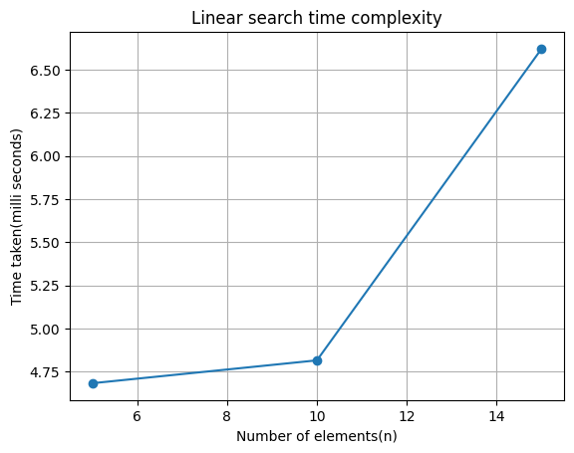

Prgm 2 binary search

Prgm 3 toh

Enter the number of disks: 2

Sequence is:

Move disk 1 s->t

Move disk 2 s->d

Move disk 1 t->d

The Number of Moves: 3

Prgm 4 Selection sort

Enter no. of trails: 3

----- > TRAIL NO: 1

Enter number of elements: 5

Sorted Array:

[5, 10, 13, 22, 41]

----- > TRAIL NO: 2

Enter number of elements: 10

Sorted Array:

[4, 5, 12, 13, 21, 26, 41, 46, 46, 47]

----- > TRAIL NO: 3

Enter number of elements: 15

Sorted Array:

[2, 9, 10, 12, 22, 29, 32, 33, 34, 36, 39, 41, 41, 43, 49]

N CPU

5 4.8

10 4.9

15 7.3

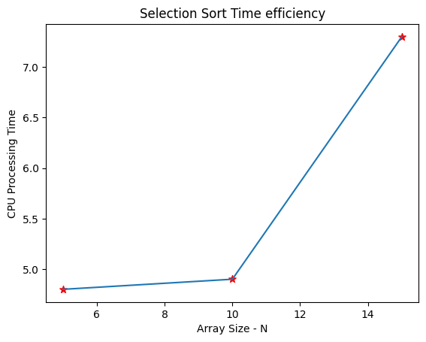

prgm 6 quick sort

Enter no.of trails: 3

---->Trail No.: 1

Enter number of elements: 5

Sorted Array:

[7, 17, 28, 36, 45]

---->Trail No.: 2

Enter number of elements: 10

Sorted Array:

[2, 4, 10, 10, 10, 19, 19, 30, 42, 45]

---->Trail No.: 3

Enter number of elements: 15

Sorted Array:

[16, 21, 22, 23, 23, 24, 25, 29, 36, 40, 42, 43, 48, 48, 48]

N,CPU

5 6.7

10 11.8

15 20.0

